31/1/2026 (19:00-24:00) Barn Owl single birds at Lhanbryde, Mosstowie, Ardivot, Fogwatt and Arradoul David Main
31/1/2026 (13:35) Green-winged Teal 1 (male) Balormie pig farm (NJ2168) Peter Stronach
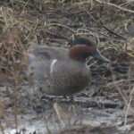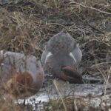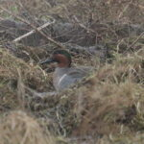
Green-winged Teal, Balormie pig farm 31 January 2026 (Peter Stronach)
31/1/2026 (13:30) Iceland/Kumlien's Gull 1 (3CY), Glaucous Gull 1 Loch Oire per Birdguides
31/1/2026 (12:00-13:00) Great Crested Grebe 1, Kingfisher 1 Nether Dallachy pool Mick Bestwick
31/1/2026 (10:00) Great Crested Grebe 1 Nether Dallachy pool Graham & Sue Larrington
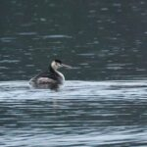
Great Crested Grebe, Nether Dallachy 31 January 2026 (Graham Larrington)
31/1/2026 (08:40-09:40) Little Gull 1 (adult), Kittiwake 10, Razorbill 2, Fulmar 2, Gannet 2, Great Northern Diver 4, Red-throated Diver 2, Long-tailed Duck 8, Common Scoter 3, Goldeneye 1, Turnstone 3 past Lossiemouth Bob Proctor
30/1/2026 Little Egret 1 Findhorn Bay Alan MacAskill
30/1/2026 White-tailed Eagle 1 near Findhorn Bay Alan MacAskill
30/1/2026 Hawfinch 2 Cawdor churchyard Alan MacAskill
30/1/1026 Merlin 1 (male), Stock Dove 1 Loch Spynie access track Alan MacAskill
30/1/2026 (12:00) Great Crested Grebe 1, Goldeneye 17, Goosander 2 Nether Dallachy pool Martin Cook
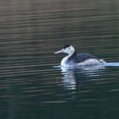
Great Crested Grebe, Nether Dallachy 30 January 2026 (Martin Cook)
30/1/2026 (08:30-09:30) Little Gull 1 (adult), Kittiwake 13, Gannet 1, Razorbill 5, Guillemot 3, Great Northern Diver 6, Common Scoter 2, Long-tailed Duck 8 past Lossiemouth Bob Proctor
30/1/2026 (09:25-11:00) Little Egret 1 Findhorn Bay (south side off rifle butts) Kevin Cuthbert, Graham & Sue Larrington
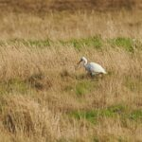
Little Egret, Findhorn Bay 30 January 2026 (Graham Larrington)
29/1/2026 Common Scoter 30, Long-tailed Duck 20, Great Northern Diver 1 Spey Bay (west end, off Lossie Forest and dunes) David Law
29/1/2026 (15:45) Hawfinch 2 Cawdor churchyard per Birdguides
29/1/2026 (am) White-fronted Goose 1 (flew in off the sea at golf course), Black-throated Diver 1, Red-throated Diver 2 (in Cullen Bay), Purple Sandpiper 10 (behind the harbour) Cullen Lenny Simpson
29/1/2026 (am) Whooper Swan 13 (flew east), Merlin 1 (male opposite Bow Fiddle Rock) Lenny Simpson
29/1/2026 (am) Little Auk 2, Brent Goose (Pale-bellied) 59, Purple Sandpiper 9 Nairn west beach Andy Chapman
28/1/2026 Hawfinch 2 Cawdor churchyard Alan MacAskill
28/1/2026 Slavonian Grebe 2, Red-throated Diver 3, Brent Goose 56, Long-tailed Duck c.150 Nairn west beach Alan MacAskill
28/1/2026 Woodcock 4 Altyre Roy Dennis
28/1/2026 Raven 2 Half Davoch Roy Dennis
28/1/2026 (11:00) Lesser Black-backed Gull 3 (adults), Herring Gull a very pale leucistic 2CY bird Loch Oire Bob Proctor
28/1/2026 (early am) Bar-tailed Godwit 20, Long-tailed Duck 2, Red-breasted Merganser 1 Lossie estuary Bob Proctor
28/1/2026 (10:00) Great Crested Grebe 1, Goldeneye 21, Tufted Duck 14, Goosander 2, Cormorant 4 Nether Dallachy pool Martin Cook
27/1/2026 (12:30-13:00) Brent Goose (Pale-bellied) 51 Nairn (shore at west golf club) Graham & Sue Larrington
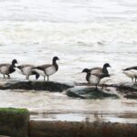
Brent Geese, Nairn 27 January 2026 (Graham Larrington)
27/1/2026 (12:20 and 15:45) Glaucous Gull 1 (2CY) Westerfolds (field at south-west corner of the airfield, with gull flock) per Birdguides
27/1/2026 (10:40) White-fronted Goose (Russian) 6 Lossiemouth-Elgin road (Windyridge - in field nearest the canal) Bob Proctor
26/1/2026 (14:55) White-fronted Goose (Russian) 6 Lossiemouth-Elgin road (in field nearest the canal) Henry Farquhar
26/1/2026 Twite 55 Nairn Bar Dave Pullan
26/1/2026 (12:35) Waxwing 2 Elgin (Lesmurdie Road/Pringle Road junction) David Main
26/1/2026 (10:20) Little Auk 1 Lossiemouth (on the sea off the harbour) Allan Lawrence
26/1/2026 (08:30-09:30) Great Northern Diver 21, Black-throated Diver 2, Red-throated Diver 4, Long-tailed Duck 21, Razorbill 25, Guillemot 5, Kittiwake 15, Woodcock 1 (flew in off the sea) past Lossiemouth Bob Proctor
26/1/2026 Hawfinch 1 Cawdor churchyard per Birdguides
26/1/2026 Snow Bunting 3 Nairn harbour Mike Taylor
26/1/2026 Purple Sandpiper 8, Red-throated Diver 8 Burghead Toni Piccolo
25/1/2026 Bearded Tit 1 Loch Spynie John Wrigley
25/1/2026 Little Auk 3, Long-tailed Duck 95 Nairn (off west beach) George Polson
25/1/2026 (14:30-15:00) White-fronted Goose (Russian) 2 near Meikle Kildrummie (NH8553, with Pink-footed Geese) Dave Pullan
25/1/2026 (13:05) Little Auk 1 Delnies (flew west) Dave Pullan
25/1/2026 (14:00) Red-breasted Merganser 1 (male) Lossie estuary Graham & Sue Larrington
25/1/2026 (11:00) Red-breasted Merganser 1 (male), Eider 20, Long-tailed Duck 3 Burghead harbour Colin Little, Allan Lawrence
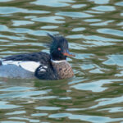
Red-breasted Merganser, Burghead harbour 25 January 2026 (Colin Little)
25/1/2026 (13:15) Little Auk 1 Burghead Richard Thaxton
25/1/2026 (13:15) Merlin 1 Lower Mill of Tynet (NJ381617) Martin Cook
25/1/2026 (13:00) Great Crested Grebe 1, Goldeneye 19 Nether Dallachy pool (NJ369639) Martin Cook
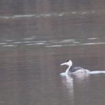
Great Crested Grebe, Nether Dallachy 25 January 2026 (Martin Cook)
25/1/2026 (12:10) Little Auk 1 Spey Bay (flew east off Tugnet) Martin Cook
25/1/2026 (12:00) Hawfinch 2 Cawdor churchyard per Birdguides
25/1/2026 (11:00) Red-throated Diver 10 (on the sea) Burghead Allan Lawrence
25/1/2026 (10:00) Tree Sparrow 41 Clochan (at garden feeders) Martin & Jenny Cook
24/1/2026 Merlin 1 Muir of Lochs (NJ30672) Stuart Massie
24/1/2026 (11:00) Hawfinch 1 Cawdor churchyard Richard Thaxton
24/1/2026 Brent Goose (Pale-bellied) 51, Long-tailed Duck 80, Eider 20 Nairn James Gordon
24/1/2026 Little Auk 3 Portknockie (on sea then flew east) per Birdguides
23/1/2026 (16:00) Goldeneye 36, Red-breasted Merganser 2 Spey estuary (from Tugnet) Keith Paterson
23/1/2026 (pm) Long-tailed Duck 60 Portgordon David Law
23/1/2026 (pm) Purple Sandpiper 32 Buckpool (at the Yardie) David Law
22/1/2026 (am) Brambling 2 Clochan (at garden feeders) David Law
22/1/2026 Purple Sandpiper 10 Nairn west beach Andy Chapman
22/1/2026 Pink-footed Goose 10,300, Pintail 540, Red-breasted Merganser 19, Dunlin 1,200 Findhorn Bay Richard Somers Cocks
21/1/2026 (13:40) Kingfisher 1 Findhorn Bay (south-west corner) Mark Jackson
21/1/2026 (14:50) Grey Partridge 14, Curlew c.120 Covesea (at the masts) Graham & Sue Larrington
21/1/2026 (late am) Hawfinch 2 Cawdor churchyard Dave Pullan
21/1/2026 (09:10-09:45) Kumlien's Gull 1 (3CY) Loch Oire Bob Proctor
20/1/2026 (08:50-09:50) Little Gull 2 (2CY), Kittiwake 1, Long-tailed Duck 4, Common Scoter 1, Red-throated Diver 1 past Lossiemouth Bob Proctor
20/1/2026 Scaup 2, Brent Goose 67, Common Scoter 12, Long-tailed Duck 145 Nairn Andy Chapman
19/1/2026 (10:25-12:00) Kumlien's Gull 1 (4CY), probable Kumlien's Gull 1 (3CY), Lesser Black-backed Gull 1 (adult) Loch Oire Bob Proctor
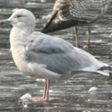
Kumlien's Gull, Loch Oire 19 January 2026 (Bob Proctor)
18/1/2026 Purple Sandpiper 13 Hopeman Mike Taylor
18/1/2026 Grey Wagtail 1 (at sewage works), Cormorant 1, Little Grebe 1 (on the river) Rothes Ian McDonald
18/1/2026 Shelduck 235, Knot 1,600, Snow Bunting 17 Nairn Bar Graeme Prest
18/1/2026 Pink-footed Goose 13,800, Greylag Goose 378, Shelduck 227, Pintail 586, Shoveler 1, Whimbrel 1, Curlew 333 Findhorn Bay Richard Somers Cocks et al.
18/1/2026 Purple Sandpiper 132, Sanderling 64 Lossiemouth Bob Proctor
18/1/2026 (11:00-13:00) Purple Sandpiper 64 (35 Buckpool, 29 Portessie), Long-tailed Duck 145, Grey Wagtail 1 (Portessie) Buckie shore Martin Cook
18/1/2026 (13:00-13:30) probable Kumlien's Gull 1 (3CY) Loch Oire Bob Proctor
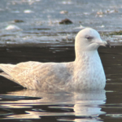
probable Kumlien's Gull, Loch Oire 18 January 2026 (Bob Proctor)
18/1/2026 (11:40) Glaucous Gull 1 (2CY) Lossie estuary per Birdguides
18/1/2026 (11:15) Kumlien's Gull 1 (4CY), Iceland Gull 1 (2CY) Loch Oire per Birdguides
17/1/2026 (14:50) White-fronted Goose (Greenland) 1 Lossiemouth-Elgin road (field between Windyridge and the canal) Henry Farquhar
17/1/2026 Blackcap 1 Inchberry Al Young
17/1/2026 Raven 1 over Dipple Al Young
17/1/2026 (pm) Hawfinch 2 Cawdor churchyard Ian McDonald
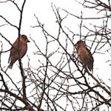
Hawfinches, Cawdor 17 January 2026 (Ian McDonald)
17/1/2026 (07:30-12:00) Iceland Gull 1 (adult), Pink-footed Goose 800, Mute Swan 95, Whooper Swan 1, Pochard 1, Goldeneye 38, Goosander 7, Coot 87, Water Rail 2 Loch Spynie David Law
17/1/2026 (am) Iceland Gull 1 (adult), Glaucous Gull (possibly Glaucous x Herring hybrid) 1 (adult) Loch Spynie Duncan Gibson
17/1/2026 (12:00) Long-tailed Duck 129 off Portgordon Martin Cook
17/1/2026 Brent Goose (Pale-bellied) 37 Nairn west beach Mike Taylor
17/1/2026 (09:10-09:35) Kumlien's Gull 1 probable (3CY), Lesser Black-backed Gull 2 still on Loch Oire Bob Proctor
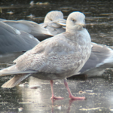
probable Kumlien's Gull, Loch Oire 17 January 2026 (Bob Proctor)
16/1/2026 (10:00-11:30) Kumlien's Gull 1 possible (3CY) Loch Oire Bob Proctor, Mark Keighley & Helen Jackson
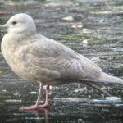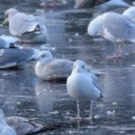
probable Kumlien's Gull, Loch Oire 16 January 2026 (Bob Proctor [left], Mark Keighley [right])
16/1/2026 (am) Hawfinch 1 Brodie Castle per Birdguides
16/1/2026 Brambling 3 Dallas (at garden feeders) Mark Bradfield
16/1/2026 (10:00-11:00) Kumlien's Gull 1 (4CY), Lesser Black-backed Gull 2 Loch Oire Bob Proctor
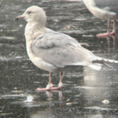
Kumlien's Gull, Loch Oire 16 January 2026 (Bob Proctor)
16/1/2026 Brambling 3 Forres (at garden feeders) Ian Wilde
16/1/2026 Hawfinch 1 Cawdor churchyard Blair Whyte
16/1/2026 Jack Snipe 3, Snipe 8 Kingsteps Blair Whyte
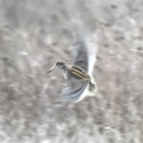
Jack Snipe, Kingsteps 16 January 2026 (Blair Whyte)
16/1/2026 Brent Goose (Pale-bellied) 52, Purple Sandpiper 4 (Seabank), Knot 1,500, Sanderling 15, Bar-tailed Godwit 62, Red-throated Diver 4, Black Guillemot 3 (near harbour) Nairn Blair Whyte
15/1/2026 Bearded Tit 1 Loch Spynie Rob Debenham
15/1/2026 Snow Bunting 2 Nairn harbour per Birdguides
15/1/2026 (11:00-15:00) Red-throated Diver 7, Common Scoter 46, Long-tailed Duck 13, Goldeneye 12, Red-breasted Merganser 5 Spey Bay (Kingston to Boar's Head Rock) David Law
15/1/2026 Red-throated Diver 6, Long-tailed Duck 34, Common Scoter 12, Red-breasted Merganser 6 Burghead Bay (from Findhorn dunes) Richard Somers Cocks
15/1/2026 (14:45) Brambling 1 Clochan (at garden feeders) Martin Cook
15/1/2026 (14:15) Hawfinch 2 Cawdor churchyard Sue & Graham Larrington
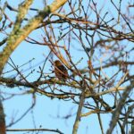
Hawfinch, Cawdor 15 January 2026 (Graham Larrington)
15/1/2026 (12:00) Iceland Gull 1 (2CY - later on Loch Oire), Herring Gull 1,400, Great Black-backed Gull 23, Wigeon 590, Mallard 220, Goosander 4, Cormorant 4 Loch na Bo Martin Cook
15/1/2026 (10:00) Hawfinch 1, Red Kite 1 Cawdor churchyard Richard Somers Cocks
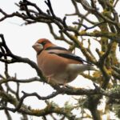
Hawfinch, Cawdor 15 January 2026 (Richard Somers Cocks)
15/1/2026 no sign of Blue-winged Teal at Loch Loy
14/1/2026 Bearded Tit 1 Loch Spynie Rob Debenham
14/1/2026 Snow Bunting 2 Findhorn beach per Birdguides
14/1/2026 Black-throated Diver 1 Burghead Bay (off Roseisle Forest car park area) per Birdguides
14/1/2026 (am) Blue-winged Teal 1 (male) still on Loch Loy (NH9358) per Birdguides
14/1/2026 (09:40) Hawfinch 3 Cawdor churchyard per Birdguides
13/1/2026 Little Egret 1 Nairn east beach C Forsyth
13/1/2026 Brent Goose (Pale-bellied) 79 Nairn (off west golf course) Stephen Keenan
13/1/2026 (09:00-11:00) Blue-winged Teal 1 (male) still on Loch Loy (NH9358 - with large Teal flock) Kevin Cuthbert
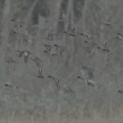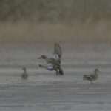
Blue-winged Teal, Loch Loy 13 January 2026 (Kevin Cuthbert)
13/1/2026 (15:30) Goldeneye 39 Tugnet (mouth of River Spey) Martin Cook
13/1/2026 (09:00-12:30) Blue-winged Teal 1 (male) still on Loch Loy (NH9358 - with large Teal flock) Dave Pullan et al.
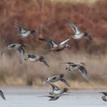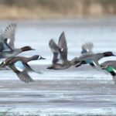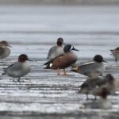
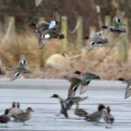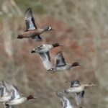
Blue-winged Teal, Loch Loy 13 January 2026 (Richard Somers Cocks)
13/1/2026 (early am) Pink-footed Goose 7,100 Findhorn Bay Richard Somers Cocks
12/1/2026 (14:15) Blue-winged Teal 1 (male) Loch Loy (NH9358 - 1st for Moray & Nairn) Dave Pullan
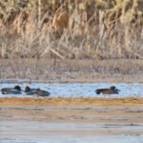
Blue-winged Teal, Loch Loy 12 January 2026 (Dave Pullan)
12/1/2026 White-fronted Goose (Russian) 1 Nether Dallachy (from footpath towards the river NJ349642) Mick Bestwick
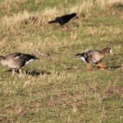
White-fronted Goose [right], Nether Dallachy 12 January 2026 (Mick Bestwick)
12/1/2026 Pintail 648, Oystercatcher 854, Whimbrel 1, Curlew 320, Dunlin 1,040 Findhorn Bay Richard Somers Cocks
11/1/2026 Iceland Gull 1 Loch Oire Andrew Stalker
11/1/2026 Purple Sandpiper 7 Burghead Andrew Stalker
11/1/2026 Hawfinch 1 Cawdor George and Rob Polson, Josh Allan
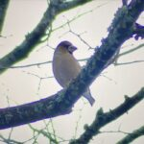
Hawfinch, Cawdor 11 January 2026 (Josh Allan)
11/1/2026 Woodlark 2 still on Lossiemouth east beach (c.1 km upstream from the caravan site - but flew off south) George and Rob Polson, Josh Allan
11/1/2026 Slavonian Grebe 1 Cummingston (500m west) Kev Cuthbert
11/1/2026 Hawfinch 3 Cawdor churchyard Andy Chapman
10/1/2026 Whooper Swan 1, Goosander 1, Woodcock 1 Cloddach quarry (mostly frozen) Robert Potter
10/1/2026 Snow Bunting 8 Nairn east beach Stephen Keenan
10/1/2026 Brent Goose (Pale-bellied) 52, Long-tailed Duck 47, Knot 1,100, Bar-tailed Godwit 37 Nairn Andy Chapman
10/1/2026 (14:15) White-fronted Goose (Greenland) 1, Greylag Goose 378, Pink-footed Goose 2, Linnet c.80 opposite Ardivot (NJ228676) Graham & Sue Larrington
10/1/2026 (12:00) Woodcock 2, Song Thrush 2 Porttannachy (just west) Martin Cook
10/1/2026 (10:00-11:50) Woodlark 2 still on Lossie estuary (in front of caravan site car park) Richard Somers Cocks et al.
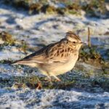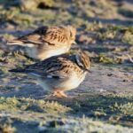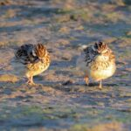
Woodlarks, Lossie estuary 10 January 2026 (Richard Somers Cocks)
9/1/2026 (13:00-15:30) Woodlark 2 Lossie estuary (in front of caravan site car park - 1st for Moray & Nairn) Mark Warren et al.
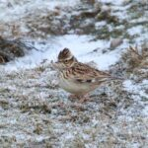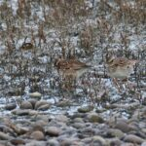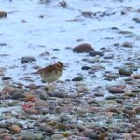
Woodlarks, Lossie estuary 9 January 2026 (Martin Cook [left & centre], Graham Larrington [right])
9/1/2026 Hawfinch 3 Cawdor churchyard Dave Pullan
9/1/2026 (11:00) Brambling 2 Spey Bay Mike Collins
9/1/2026 Brambling 1 Conicavel Dave Slater
9/1/2026 (am) Snipe 3, Woodcock 1, Barn Owl 1 Portknockie (east end) Lenny Simpson
9/1/2026 (10:45) Song Thrush 2 Clochan Martin & Jenny Cook
8/1/2026 (12:00) Grey Partridge 11 Covesea (on stubbles around the aerials) Graham & Sue Larrington
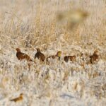
Grey Partridge, Covesea 8 January 2026 (Graham Larrington)
8/1/2026 Purple Sandpiper 14, Long-tailed Duck 200 Nairn (west beach) Beryl Blackhall
7/1/2026 Goldeneye 26, Pochard 1, Coot 42, Mute Swan 82 Loch Spynie Richard Somers Cocks
7/1/2026 (13:00-14:00) Skylark c.3500, Common Gull c.2,500, Grey Partridge 6 Covesea (on stubbles around the aerials) Graham & Sue Larrington
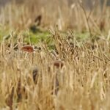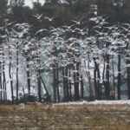
Grey Partridge and Common Gulls, Covesea 7 January 2026 (Graham Larrington)
7/1/2026 (10:30) Long-tailed Duck 4, Eider 9 Burghead harbour Graham & Sue Larrington
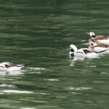
Long-tailed Ducks, Burghead harbour 7 January 2026 (Graham Larrington)
7/1/2026 Gadwall 1, Coot c.80, Mute Swan 71 Loch Spynie Allan Lawrence
6/1/2026 Twite 54, Oystercatcher 949, Golden Plover 57, Knot 670, Dunlin 1,125 Findhorn Bay Richard Somers Cocks
6/1/2026 (12:45) Brambling 1 (male) Lossiemouth (Fulmar Road garden) Henry Farquhar
6/1/2026 Snow Bunting 6 Nairn east beach Andy Chapman
5/1/2026 (12:00) Kingfisher 1 Tugnet (on Pottie Burn) Mike Collins
5/1/2026 Sanderling 51 Lossiemouth Allan Lawrence
5/1/2026 Brambling 1, Linnet 500+ Nairn (Househill) Dave Pullan
5/1/2026 Snow Bunting 1 (flew west over the sea), Song Thrush 3 Nairn Dave Pullan
5/1/2026 (15:00) Fieldfare 26 Inverugie garden Graham & Sue Larrington
5/1/2026 (14:30) Skylark 150+ near Hillside Cemetery (Portknockie-Findochty) Lenny Simpson
5/1/2026 (14:00) Purple Sandpiper 10 Nairn (west beach) Peter Duncan
5/1/2026 (14:00) Grey Partridge 2 Pittendreich David & Eileen Main
5/1/2026 Pintail 652, Shelduck 308, Golden Plover 71, Bar-tailed Godwit 72, Song Thrush 2 Findhorn Bay Richard Somers Cocks
5/1/2026 (am) Song Thrush 4, Blackcap 1 (male) Portknockie Lenny Simpson
5/1/2026 (am) Skylark c.2,000 Covesea (on stubbles around the aerials) Allan Lawrence
4/1/2026 (12:25) White-tailed Eagle 1 (immature) Nairn (drifted east over Househill) Dave Pullan
4/1/2026 Red Kite 1 Nairn (Househill) Dave Pullan
4/1/2026 Brent Goose (Pale-bellied) 47, Purple Sandpiper 12, Long-tailed Duck 40, Common Scoter 4 Nairn (off west golf course) Blair Whyte
4/1/2026 (12:55) Little Auk 2 Burghead (on the sea to the east) per Birdguides
4/1/2026 (am) Water Rail 1 Miltonduff Chrissie Kelly
4/1/2026 Woodcock 1, Snipe 1 (along old railway line), Peregrine 2 (flew over) Portknockie Lenny Simpson
4/1/2026 Song Thrush 1 Preshome (Clochan) David Law
3/1/2026 Woodcock 1 Clochan David Law
3/1/2026 Brambling 1 Dallas Mark Bradfield
3/1/2026 Brent Goose (Pale-bellied) 24 Nairn shore BirdTrack
3/1/2026 Grey Partridge 6 Howford Bridge (Nairn) Peter Duncan
2/1/2026 (pm) Iceland Gull 1 (2CY) Cullen (flew west) Rob Archer
1/1/2026 Little Auk 1 Burghead George and Rob Polson
1/1/2026 (01:00) Barn Owl 1 Elgin-Lossiemouth road near the canal David Main
1/1/2026 (10:30) Peregrine 1 Cloddymoss (fields to south) Mark Jackson
1/1/2026 (am) Kingfisher 1 Netherton steading (south of Findhorn Bay) Roy Dennis
1/1/2026 (am) Grey Partridge 3 Findhorn Bay Roy Dennis
1/1/2026 (pm) Iceland Gull 1 (adult) Loch Oire per Birdguides

