30/9/2025 (14:00-15:00) Curlew Sandpiper 1, Ruff 2, Little Gull 1 Lossie estuary Richard Somers Cocks
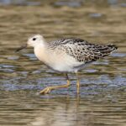
Ruff, Lossie estuary 30 September 2025 (Richard Somers Cocks)
29/9/2025 Snipe 3, Little Grebe 2, Goldeneye 1 Spey estuary (east side) Keith Paterson
29/9/2025 (14:00) White-tailed Eagle 1 Findhorn Bay Richard Somers Cocks
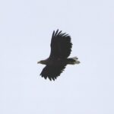
White-tailed Eagle, Findhorn Bay 29 September 2025 (Richard Somers Cocks)
29/9/2025 (09:20) Wheatear 2, Skylark c.40 RAF Lossiemouth Allan Lawrence
29/9/2025 (08:00) Osprey 1 Findhorn Bay Richard Somers Cocks
28/9/2025 (20:30) Barnacle Goose 2+ (heard) Bishopmill (Elgin) Bob Proctor
28/9/2025 (16:10) Curlew Sandpiper 1, Ruff 2, Grey Plover 1 (west) Lossie estuary Duncan Gibson
28/9/2025 (14:15) Purple Sandpiper 26, Turnstone 36 Lossiemouth harbour Graham & Sue Larrington
28/9/2025 Greenshank 1, Kingfisher 1 Mosset Burn (Findhorn Bay) Allan Lawrence
28/9/2025 (07:50-08:50) Manx Shearwater 2, Long-tailed Duck 6, Common Scoter 7, Red-throated Diver 3, Gannet 186, Kittiwake 17, Guillemot 4, Razorbill 9, Black Guillemot 22, Wigeon 5, Red-breasted Merganser 1, Grey Heron 1 (south), Carrion Crow 5 (south) passed Lossiemouth Bob Proctor
27/9/2025 (16:20) Curlew Sandpiper 1 Lossie estuary Duncan Gibson
27/9/2025 (11:30) Barnacle Goose 17 (10 over, 7 landed), Ruff 1 Lossie estuary Graham & Sue Larrington
27/9/2025 (11:00) Barnacle Goose 13 Lossie estuary Graham & Sue Larrington
27/9/2025 (09:00-09:30) Barnacle Goose 10, Bar-tailed Godwit 13 Lossie estuary Bob Proctor
27/9/2025 (07:50-08:50) Barnacle Goose 6, Manx Shearwater 2, Common Scoter 28, Fulmar 1, Gannet 199, Razorbill 303, Guillemot 9, Black Guillemot 3, Kittiwake 31, Sandwich Tern 1, Common Tern 2, Wigeon 25, Teal 2 passed Lossiemouth Bob Proctor
26/9/2025 (13:00) Barnacle Goose 3 Spey estuary (east side) Keith Paterson
26/9/2025 (06:30 - 08:30) White-tailed Eagle 1, Osprey 1, Pink-footed Goose 53,400 Findhorn Bay Richard Somers Cocks
25/9/2025 Bearded Tit 5, Marsh Harrier 1 Loch Spynie Adele Clark
25/9/2025 (17:40-17:50) Curlew Sandpiper 1, Little Gull 1 (1CY) Lossie estuary Duncan Gibson
25/9/2025 (16:50) Ruff 3 Lossie estuary Henry Farquhar
25/9/2025 (afternoon) White-tailed Eagle 1, Kingfisher 1 Findhorn Bay Dave Pullan
25/9/2025 (afternoon) Wheatear 1 Findhorn beach Richard Somers Cocks
25/9/2025 (morning) Osprey 1 Findhorn Bay per Richard Somers Cocks
25/9/2025 (08:30-09:30) White-tailed Eagle 1 (adult flying west), Peregrine 1, Pintail 124, Barnacle Goose 1, Pink-footed Goose 30,000+, Greylag Goose 16, Canada Goose 7, Shelduck 14, Redshank 686 Findhorn Bay Richard Somers Cocks
25/9/2025 (08:00) Skylark 2 (south) Bishopmill (Elgin) Bob Proctor
24/9/2025 (18:30) Little Gull 1 (adult), Grey Plover 1 Lossie estuary Duncan Gibson
24/9/2025 Chiffchaff 2 Tomnamoon (NJ0450) Mike Crutch
24/9/2025 (08:30) Chiffchaff 1 (still singing) Elgin cemetery Bob Proctor
24/9/2025 (07:10-07:50) Marsh Harrier 2 (juvenile), Pochard 1 (male), Whooper Swan 18 Loch Spynie Graham & Sue Larrington
23/9/2025 Bearded Tit 26 Loch Spynie (at the hide) Pamela Hay
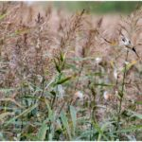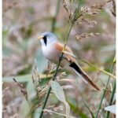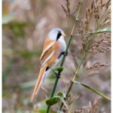
Bearded Tits, Loch Spynie 23 September 2025 (Pamela Hay)
23/9/2025 (overnight) Quail 1 (trapped) Burnside of Dipple Alastair Young
23/9/2025 (16:35) Glossy Ibis 1 (in off sea, then flew east towards Nairn) Delnies Dave Pullan
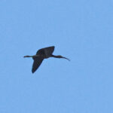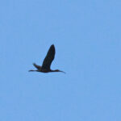
Glossy Ibis, Delnies 23 September 2025 (Dave Pullan)
23/9/2025 (15:45) Marsh Harrier 1 (female), Bearded Tit 1 (female), Pochard 1 (male), Scaup 1 (female), Gadwall 5 Loch Spynie Alan MacAskill
23/9/2025 Ruff 1, Curlew Sandpiper 1, Bar-tailed Godwit 16, Dunlin 24, Ringed Plover c.30, Sandwich Tern Lossie estuary Alan MacAskill
23/9/2025 Black-tailed Godwit 2, Greenshank 1 Mosset Burn (mouth) Alan MacAskill
23/9/2025 Whooper Swan 3, Pink-footed Goose c.60,000 Findhorn Bay Alan MacAskill
23/9/2025 Sandwich Tern 21, Bar-tailed Godwit 10, Knot c.80 Nairn harbour Alan MacAskill
23/9/2025 (15:10) Curlew Sandpiper 3 Lossie estuary Allan Lawrence
23/9/2025 (13:55) Chiffchaff 1 (still singing) Tomnamoon (NJ0450) Mike Crutch
23/9/2025 (05:05) Barn Owl 1 Roseisle Graham & Sue Larrington
22/9/2025 Pink-footed Goose 5,000+ Kinloss Pete & Jo Graham
22/9/2025 Ruff 2, Black-tailed Godwit 4, Pink-footed Goose 6 Spey estuary (east side) Keith Paterson
22/9/2025 Pomarine Skua 1 Lossiemouth harbour Ian Bell
22/9/2025 (06:15-08:45) Pink-footed Goose 62,600 Findhorn Bay Richard Somers Cocks
21/9/2025 (14:30-15:30) Manx Shearwater 3, Gannet 273, Black Guillemot 3, Guillemot 14, Razorbill 17, Kittiwake 6, Wigeon 1, Bar-tailed Godwit 1 passed Lossiemouth Bob Proctor
21/9/2025 Whimbrel 1, Osprey 1, Pink-footed Goose c.20,000 Findhorn Bay Blair Whyte
21/9/2025 Black-tailed Godwit 6, Ringed Plover 7, Turnstone 3, Sanderling 11 Delnies Paulo Bessa
21/9/2025 (10:40) Osprey 1 Findhorn Bay Mike Crutch
21/9/2025 (09:00) White-tailed Eagle 1 (adult), Osprey 1 Richard Somers Cocks
21/9/2025 (08:45-09:40) Bar-tailed Godwit 13, Teal 185, Wigeon 79, Skylark 67, Meadow Pipit 4 Lossie estuary Bob Proctor
21/9/2025 (07:30-08:30) Great Skua 1, Little Gull 1 (adult), Common Scoter 14, Gannet 201, Black Guillemot 6, Razorbill 66, Guillemot 5, Kittiwake 38, Common Tern 1, Red-breasted Merganser 1 passed Lossiemouth Bob Proctor
21/9/2025 (overnight) Quail 3 (trapped), Golden Plover 18 Burnside of Dipple Alastair Young
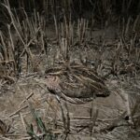
Quail, Burnside of Dipple 21 September 2025 (Alastair Young)
20/9/2025 (17:00-19:00) Long-tailed Skua 1 (1CY), Arctic Skua 2, Great Skua 3, Sooty Shearwater 7, Manx Shearwater 32, Little Gull 1 (adult), Fulmar 70, Common Scoter 19, Red-throated Diver 3, Gannet 482, Razorbill 65, Guillemot 39, Kittiwake 103, Sandwich Tern 6, Common Tern 3, Wigeon 103, Bar-tailed Godwit 1 passed Lossiemouth Bob Proctor
20/9/2025 Spotted Redshank 1 Delnies Dave Pullan
20/9/2025 (11:00) Whooper Swan 26 (2 groups east) Tugnet Keith Paterson
20/9/2025 (10:35) Pintail 1 (female) Mosset pond, Forres Allan Lawrence
20/9/2025 (10:25) Common Scoter c.100 Boar's Head Rock area Graham & Sue Larrington
20/9/2025 (08:45) Grey Partridge 12 Crosslots, Duffus (NJ179672) Graham & Sue Larrington
20/9/2025 (07:05-09:05) Sooty Shearwater 22, Manx Shearwater 14, Arctic Skua 6, Little Gull 1 (adult), Common Scoter 16, Red-throated Diver 11, Fulmar 9, Gannet 287, Razorbill 167, Guillemot 98, Black Guillemot 8, Kittiwake 38, Pink-footed Goose 256, Wigeon 35, Red-breasted Merganser 2 passed Lossiemouth Bob Proctor
19/9/2025 Curlew Sandpiper 2, Little Gull 2, Ruff 1 Lossie estuary Neil Sutherland
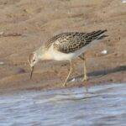 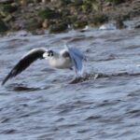
Ruff and Little Gull, Lossie estuary 19 September 2025 (Neil Sutherland)
19/9/2025 (12:00-14:30) Curlew Sandpiper 2 Lossie estuary Kevin Cuthbert
19/9/2025 (08:00-11:00) Merlin 2, Peregrine 1, Pink-footed Goose 40-50,000 Findhorn Bay Kevin Cuthbert
19/9/2025 (early am) Pink-footed Goose c.41,500 (more still arriving) Findhorn Bay Richard Somers Cocks
18/9/2025 (17:20-18:20) Little Gull 1 (adult), Arctic Skua 2, Red-throated Diver 2, Fulmar 2, Gannet 135, Kittiwake 32, Razorbill 3, Pink-footed Goose 74, Knot 1, Dunlin 2 passed Lossiemouth Bob Proctor
18/9/2025 (15:00) Ruff 2 Portgordon harbour Keith Paterson
18/9/2025 (14:00) Curlew Sandpiper 1 Lossie estuary (car park) Graham & Sue Larrington
18/9/2025 (10:30) Pink-footed Goose 3,000+ Findhorn Bay Graham & Sue Larrington
18/9/2025 (07:05-08:05) Pomarine Skua 1, Arctic Skua 1, Common Scoter 9, Fulmar 3, Gannet 162, Red-throated Diver 1, Razorbill 7, Guillemot 3, Black Guillemot 2, Kittiwake 34, Sandwich Tern 4, Ruff 2, Turnstone 2 passed Lossiemouth Bob Proctor
17/9/2025 (16:15) Little Gull 2 Lossie estuary Henry Farquhar, Richard Thaxton
17/9/2025 (14:30) White-tailed Eagle 1 (adult south), Pink-footed Goose 3,440 Richard Somers Cocks, Gordon McMullins
16/9/2025 (15:30) Ruff 3, Snipe 1 Spey estuary (east side) Keith Paterson
16/9/2025 (13:30) Ruff 1, Black-tailed Godwit 7, Dunlin 2, Wheatear 1 Spey estuary (west side) Raymond Shewan
16/9/2025 (13:25) Curlew Sandpiper 2, Little Gull 1 Lossie estuary Allan Lawrence
16/9/2025 (am) Curlew Sandpiper 2, Little Stint 1, Sanderling 1, Dunlin 123, Knot 4, Bar-tailed Godwit 8, Ringed Plover 21, Oystercatcher 557 Findhorn Bay Gordon McMullins
16/9/2025 (am) Curlew Sandpiper 2, Osprey 6 Findhorn Bay Ian McDonald
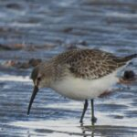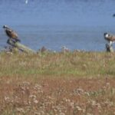
Curlew Sandpiper and Ospreys, Findhorn Bay 16 September 2025 (Ian McDonald)
16/9/2025 (09:30-10:15) Bar-tailed Godwit 24, Oystercatcher 62, Dunlin 17, Ringed Plover 36, Sanderling 2, Shelduck 1, Goosander 14, Teal 80, Wigeon 83, Meadow Pipit 12 Lossie estuary Graham & Sue Larrington
16/9/2025 (10:45-11:00) Little Gull 1 (adult), Curlew Sandpiper 1, Ruff 4, Greylag Goose c.185 Lossie estuary and upstream Raymond Shewan
16/9/2025 (07:50-08:30) Sooty Shearwater 1, Fulmar 1, Gannet 112, Kittiwake 3, Sandwich Tern 2, Red-throated Diver 1, Eider 10, Common Scoter 6 past Lossiemouth Graham & Sue Larrington
16/9/2025 (15:45) Osprey 4 Findhorn Bay Mike Crutch, Roy Dennis
15/9/2025 (am) Whooper Swan 2 Loch Spynie Pamela Hay
15/9/2025 (pm) Little Stint 2, Curlew Sandpiper 2, Dunlin 109, Ringed Plover 48, Black-tailed Godwit 9, Pink-footed Goose 1,040 Findhorn Bay Richard Somers Cocks
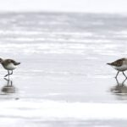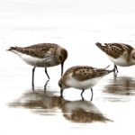
Curlew Sandpipers [left] and Little Stints [right with a Dunlin], Findhorn Bay 15 September 2025 (Richard Somers Cocks)
15/9/2025 (pm) Whimbrel 1 Lossie estuary Kevin Cuthbert
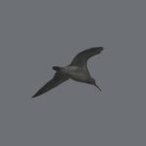
Whimbrel, Lossie estuary 15 September 2025 (Kevin Cuthbert)
15/9/2025 (12:00-14:00) Sooty Shearwater 40+, Manx Shearwater many, Arctic Skua 8, Great Skua 6 past Lossiemouth Kevin Cuthbert
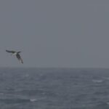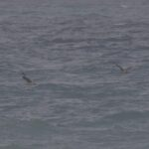
Arctic Skuas [left] and Great Skuas, passing Lossiemouth 15 September 2025 (Kevin Cuthbert)
15/9/2025 (16:00) Little Gull 1 Lossie estuary per Birdguides
15/9/2025 Pink-footed Goose c.30 Nairn Ross Macleod
15/9/2025 Curlew Sandpiper 6, Ruff 2, Knot 4, Bar-tailed Godwit 20 Lossie estuary Ross Macleod
14/9/2025 (17:00-18:00) Ruff 5, Fulmar 7, Gannet 100, Razorbill 9, Guillemot 34, Kittiwake 6, Sandwich Tern 5, Common Tern 2, Turnstone 2, Red-throated Diver 1, Grey Heron 1 (far out above the turbines) past Lossiemouth Bob Proctor
14/9/2025 (16:30) Curlew Sandpiper 6, Ruff 1, Knot 3, Bar-tailed Godwit 20, Black-tailed Godwit 1, Redshank 30+ Lossie estuary Henry Farquhar
14/9/2025 (13:00-15:00) Curlew Sandpiper 1, Ruff 1, Whimbrel 1 (flew west), Bar-tailed Godwit 23, Sanderling 11, Ringed Plover 26, Wigeon 86, Teal 192, Pink-footed Goose 36 (flew in off the sea), Great Black-backed Gull 244, Lesser Black-backed Gull 2 Lossie estuary Richard Somers Cocks
14/9/2025 Great Skua 1, Peregrine 1, Wheatear 2 Portknockie Ross Macleod
14/9/2025 (am) Little Stint 1, Curlew Sandpiper 2, Dunlin 83, Knot 2, Sanderling 1, Black-tailed Godwit 1, Bar-tailed Godwit 1, Golden Plover 6, Ringed Plover 4 Findhorn Bay Gordon McMullins
14/9/2025 (pm) Marsh Harrier 1, Osprey 3, Pink-footed Goose c.440 Findhorn Bay Graham & Sue Larrington
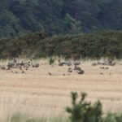
Pink-footed Geese, Findhorn Bay 14 September 2025 (Graham Larrington)
14/9/2025 Bar-tailed Godwit 48 Burghead (at roost) Kevin Cuthbert
14/9/2025 (11:00) Ruff 2, Black-tailed Godwit 8, Curlew 115, Turnstone 17, Canada Goose 45 Spey estuary Martin Cook
14/9/2025 Kingfisher 1 Rothes (River Spey) Ian McDonald
14/9/2025 (am) Curlew Sandpiper 1 Lossie estuary Colin Little
14/9/2025 (15:00) Pink-footed Goose c.70 over Nairn Peter Duncan
14/9/2025 (07:15-08:45) Curlew Sandpiper 1, Black-tailed Godwit 5, Pink-footed Goose 588 (included 15 flocks arriving in the bay), Greylag Goose 278, Canada Goose 1 Findhorn Bay Richard Somers Cocks
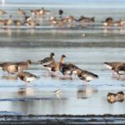
Curlew Sandpiper [front centre] with Pink-footed Geese, Findhorn Bay 14 September 2025 (Richard Somers Cocks)
14/9/2025 (08:15-09:15) Little Gull 1 (adult), Great Skua 1, Fulmar 23, Gannet 55, Razorbill 1, Kittiwake 4, Sandwich Tern 40, Common Scoter 10, Bar-tailed Godwit 9 past Lossiemouth Bob Proctor
14/9/2025 (08:20-09:00) Red-breasted Merganser 27, Eider 38, Razorbill 9, Bar-tailed Godwit 1 Burghead Bay Graham & Sue Larrington
14/9/2025 (07:50) Pink-footed Goose c.50 Inverugie (flew over) Graham & Sue Larrington
13/9/2025 Greenshank 6, Wheatear 2 Delnies Dave Pullan
13/9/2025 (late am) Curlew Sandpiper 2, Ruff 4, Greenshank 1, Little Gull 1 Lossie estuary Kevin Cuthbert
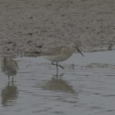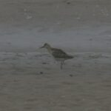
Curlew Sandpiper [left, with Dunlin] and Ruff, Lossie estuary 13 September 2025 (Kevin Cuthbert)
13/9/2025 Whimbrel 1, Gannet c.100, Razorbill c.30, Guillemot c.20, Fulmar c.20, Sandwich Tern 5, Wheatear 2, Swift 1 Findochty Ross Macleod
13/9/2025 Curlew Sandpiper 1 Lossie estuary Andy Chapman
13/9/2025 (early am) Marsh Harrier 1 Loch Spynie Rob Debenham
13/9/2025 (am) Ruff 4, Black-tailed Godwit 10, Kingfisher 1, Common Scoter 15 (offshore) Spey estuary Ross Macleod
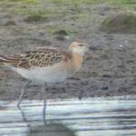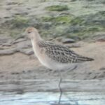
Ruff, Spey estuary 13 September 2025 (Ross Macleod)
13/9/2025 (10:30-11:30) Ruff 4, Black-tailed Godwit 10, Canada Goose 62, Greylag Goose 37, Pink-footed Goose 1, Teal 90, Wigeon 76, Wheatear 1 Spey estuary Martin Cook
13/9/2025 (08:30-10:00) Osprey 16, Pink-footed Goose 119 (including 4 small flocks arriving from the north) Findhorn Bay Richard Somers Cocks
12/9/2025 (11:20) Whooper Swan 1 Loch Oire Graham & Sue Larrington
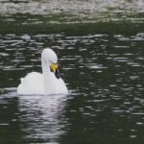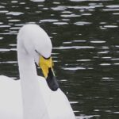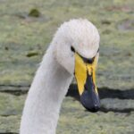
Whooper Swans, Loch Oire 12 September 2025 [left and centre] (Graham Larrington) and Cloddach quarry [right] 11 September 2025 (Richard Somers Cocks). A single Whooper Swan has been seen at these two sites on several dates over the summer. These pictures show the different bill patterns, confirming that different birds are involved.
12/9/2025 (pm) Whooper Swan 1 Loch Oire Ross Macleod
12/9/2025 (pm) Osprey 12, Peregrine 1 Findhorn Bay Ross Macleod
12/9/2025 (15:00) Little Stint 1 Lossie estuary per Birdguides
12/9/2025 (early am) Pintail 66, Black-tailed Godwit 11, Redshank 716 Findhorn Bay Richard Somers Cocks
12/9/2025 (early am) Kingfisher 1 Loch Spynie Ian Litster
12/9/2025 (am) Curlew Sandpiper 1, Osprey 7 Findhorn Bay Paulo Bessa
12/9/2025 (early am) Osprey 12 Findhorn Bay Richard Somers Cocks, Mike Crutch
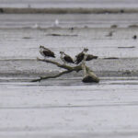
Ospreys, Findhorn Bay 12 September 2025 (Mike Crutch)
11/9/2025 (18:10) Curlew Sandpiper 11, Knot 5 Lossie estuary Henry Farquhar
11/9/2025 (late am) Gadwall 27, Whooper Swan 1, Grey Wagtail 7 (on River Lossie) Cloddach quarry Richard Somers Cocks, Tom Dewick
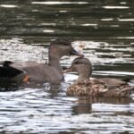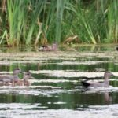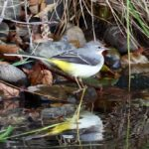
Gadwall and Grey Wagtail, Cloddach quarry 11 September 2025 (Richard Somers Cocks)
11/9/2025 (16:40) Red Kite 1 Lethen Jack Harrison
11/9/2025 (12:00) Grey Partridge 5 Pittendreich David Main
11/9/2025 (13:20) Black Tern 1 (flew east), Arctic Skua 1 off Nairn harbour Dave Pullan
11/9/2025 (12:00-12:30) Black-tailed Godwit 8, Greenshank 2, Teal 110, Wigeon 24, Goosander 82, Cormorant 12, Grey Heron 5 Spey estuary and river mouth Martin Cook
11/9/2025 (09:30-10:30) Osprey 19 Findhorn Bay Martin Cook
11/9/2025 (08:30) Canada Goose 35+ Alves (flew over) Roy Anderson
10/9/2025 (13:00) Wheatear 1 Portknockie (Bow Fiddle Rock area) Clive Pell
10/9/2025 (09:30-12:00) Curlew Sandpiper 1, Ruff 2, Knot 7, Bar-tailed Godwit 16, Little Gull 1, Razorbill 1 Lossie estuary Dave Pierce
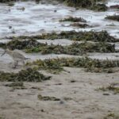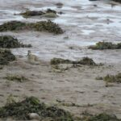
Curlew Sandpiper, Lossie estuary 10 September 2025 (Dave Pierce)
10/9/2025 (17:10-18:10) Little Gull 1 (adult), Manx Shearwater 14, Fulmar 40, Gannet 86, Black Guillemot 1, Guillemot 6, Razorbill 11, Kittiwake 7, Sandwich Tern 6, Common Tern 1, Red-throated Diver 1, Common Scoter 2, Grey Heron 1 past Lossiemouth Bob Proctor
10/9/2025 (early am) Osprey 19, Red Kite 1 Findhorn Bay Richard Somers Cocks
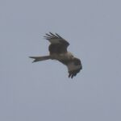
Red Kite. Findhorn Bay 10 September 2025 (Richard Somers Cocks)
10/9/2025 (09:30) Black-tailed Godwit 9, Lapwing 101, Curlew 38, Snipe 3, Greylag Goose 51, Little Grebe 3 Spey estuary (west side) Raymond Shewan
10/9/2025 (09:30) Osprey 20 Findhorn Bay Mike Crutch
9/9/2025 Osprey 18, Grey Heron 21, Redshank 754, Canada Goose 148, Greylag Goose 908, Teal 264 Findhorn Bay Richard Somers Cocks
9/9/2025 Great Skua 1, Common Scoter 18 Burghead Bay (from Findhorn dunes) Richard Somers Cocks
9/9/2025 (15:50) Curlew Sandpiper 9 (possibly more) Lossie estuary Henry Farquhar
9/9/2025 (07:30-11:30) Curlew Sandpiper 3, Greenshank 2, Oystercatcher 42, Curlew 25, Ringed Plover 20, Bar-tailed Godwit 12, Redshank 32, Wigeon 36, Teal 67, Mallard 110, Goosander 15, Grey Heron 11, Kingfisher 1, Wheatear 1 Lossie estuary Graham & Sue Larrington
9/9/2025 (09:45-10:45) Ruff 4, Greenshank 3, Black-tailed Godwit 8, Redshank 4, Lapwing 155, Curlew 89, Turnstone 16, Canada Goose 58, Greylag Goose 46, Teal 92, Wigeon 59 Spey estuary Martin Cook
9/9/2025 (early am) Osprey 18 Findhorn Bay Mike Crutch
8/9/2025 (evening) Ruff 11, Whimbrel 1 (flew west), Red-breasted Merganser 29 Delnies Dave Pullan
8/9/2025 (16:00) Curlew Sandpiper 2, Sanderling 7, Dunlin 12, Ringed Plover 27, Bar-tailed Godwit 7, Shelduck 2 Lossie estuary Graham & Sue Larrington
8/9/2025 (am) Osprey 17, Pink-footed Goose 73, Pintail 72, Wigeon 269, Teal 241, Black-tailed Godwit 10, Peregrine 1 Findhorn Bay Richard Somers Cocks
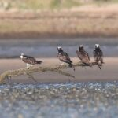
Ospreys, Findhorn Bay 8 September 2025 (Richard Somers Cocks)
8/9/2025 (10:30-11:15) Curlew Sandpiper 2, Ruff 1 Lossie estuary Allan Lawrence
8/9/2025 (am) Pomarine Skua 1 Nairn (off west beach) per Birdguides
8/9/2025 (10:30) Curlew Sandpiper 1 Lossie estuary (c.2 km upstream) Raymond Shewan
8/9/2025 (07:30) Ruff 1, Greenshank 1, Lapwing 87, Canada Goose 30, Little Grebe 3 Spey estuary (west side) Raymond Shewan
7/9/2025 Bar-tailed Godwit 34, Redshank 62, Knot 83, Sanderling 6, Arctic Skua 1 Nairn east beach Andy Chapman
7/9/2025 (late pm) Curlew Sandpiper 2, Greenshank 2 Lossie estuary Henry Farquhar, Graham & Sue Larrington
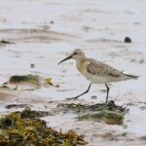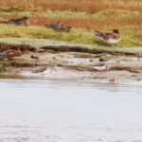
Curlew Sandpiper and Greenshanks, Lossie estuary 7 September 2025 (Graham Larrington)
7/9/2025 (07:45-09:45) Pomarine Skua 1, Great Skua 2, Arctic Skua 3, Manx Shearwater 8, Fulmar 277, Gannet 738, Razorbill 44, Guillemot 12, Black Guillemot 1, Kittiwake 56, Sandwich Tern 33, Common Tern 14, Red-throated Diver 2, Common Scoter 32, Teal 5, Bar-tailed Godwit 1, Grey Heron 1 past Lossiemouth Bob Proctor
7/9/2025 (09:30) Curlew Sandpiper 1 still on Lossie estuary Graham & Sue Larrington
7/9/2025 (08:00) Osprey 19 Findhorn Bay (perched on logs and trees in the bay at low tide) Richard Somers Cocks
7/9/2025 (07:20-07:40) Curlew Sandpiper 1, Ruff 1, Teal 139 Lossie estuary Bob Proctor
6/9/2025 (19:50) Curlew Sandpiper 1 Lossie estuary Blair Whyte
6/9/2025 (evening) Whimbrel 5, Black-tailed Godwit 5, Basking Shark 1 Delnies Dave Pullan
6/9/2025 (12:45) Kingfisher 1 Nether Dallachy pool Gav Troon
6/9/2025 (15:30-16:30) Curlew Sandpiper 1, Ruff 1, Black-tailed Godwit 1, Knot 1, Little Gull 1 Lossie estuary Henry Farquhar, Duncan Gibson
6/9/2025 Peregrine 1 Tarras Allan Lawrence
6/9/2025 (16:00) Pintail 2 (females), Canada Goose 60 Spey estuary (east side) Martin Cook
6/9/2025 (am) Ruff 1 Spey estuary (east side) Keith Paterson
6/9/2025 (08:00-10:00) Bar-tailed Godwit 17, Ruff 1, Greenshank 1, Redshank 62, Knot 2, Little Gull 1, Teal 91, Goosander 14, Kingfisher 1 Lossie estuary and upriver Graham & Sue Larrington
6/9/2025 Goshawk 1 (juvenile), Marsh Harrier 1 (juvenile) Loch Spynie Dougie Fergus
6/9/2025 (06:30-07:30) Gannet 160, Fulmar 10, Sandwich Tern 54, Common Tern 7, Red-throated Diver 2, Common Scoter 14, Meadow Pipit 5 (in off the sea) past Lossiemouth Bob Proctor
6/9/2025 Curlew Sandpiper 1, Knot 3, Dunlin 85, Oystercatcher 932, Osprey 11 Findhorn Bay Richard Somers Cocks
5/9/2025 Whooper Swan 1 Loch Oire Richard Somers Cocks, Tom Dewick
5/9/2025 Canada Goose 37 Spey estuary Richard Somers Cocks, Tom Dewick
5/9/2025 (13:00-14:00) Curlew Sandpiper 1, Little Gull 1 (adult) Lossie estuary Richard Somers Cocks, Tom Dewick
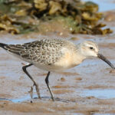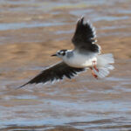
Curlew Sandpiper and Little Gull, Lossie estuary 5 September 2025 (Richard Somers Cocks)
5/9/2025 (12:00) Marsh Harrier 1 (juvenile) Loch Spynie Richard Somers Cocks, Tom Dewick
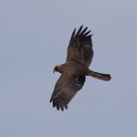
Marsh Harrier, Loch Spynie 5 September 2025 (Richard Somers Cocks)
5/9/2025 (16:30) Wheatear 1 Findochty David Law
5/9/2025 (13:00) Peregrine 1 Clochan David Law
5/9/2025 (early am) Canada Goose 174, Greylag Goose 830, Grey Heron 23, Osprey 8 Findhorn Bay Richard Somers Cocks
5/9/2025 Osprey 10 Findhorn Bay Alan MacAskill, Dave Barnett
5/9/2025 Curlew Sandpiper 1, Ruff 1, Bar-tailed Godwit 13, Sanderling 28, Dunlin 16, Ringed Plover 34 Lossie estuary Alan MacAskill, Dave Barnett
5/9/2025 (10:00) Little Gull 1 (adult) Lossie estuary Allan Lawrence
4/9/2025 Whimbrel c.30, Kingfisher 2 Spey estuary (west side) Neil Sutherland & Carol Armour
4/9/2025 (15:55) Curlew Sandpiper 1 still on Lossie estuary Henry Farquhar
4/9/2025 Kingfisher 1 Rothes (River Spey) Ian McDonald
4/9/2025 (15:00-16:00) Ruff 3, Whimbrel 1, Lapwing 57, Teal 49 Spey estuary (east side) Martin Cook
4/9/2025 (am) Common Scoter 12 Spey Bay (off Tugnet) Keith Paterson
4/9/2025 Kingfisher 1 Loch Spynie Margaret Reuss-Newland
4/9/2025 (13:15) Curlew Sandpiper 1, Little Gull 1 Lossie estuary John Poyner
4/9/2025 (07:30-09:00) Osprey 12, Pink-footed Goose 26, Pintail 39, Wigeon 292, Teal 123, Shoveler 2, Curlew 328, Redshank 533, Dunlin 109, Ringed Plover 24 Findhorn Bay Richard Somers Cocks
3/9/2025 (15:00) Ruff 4, Greenshank 1 Spey estuary (east side) Martin Cook
3/9/2025 (pm) Osprey 7 Findhorn Bay Mike Crutch, Roy Dennis
3/9/2025 (early am) Swallow c.130 Lethen Jack Harrison
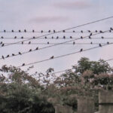
Swallows, Lethen 3 September 2025 (Jack Harrison)
2/9/2025 (18:35-19:35) Arctic Skua 6, Great Skua 1, Fulmar 25, Gannet 60, Kittiwake 54, Sandwich Tern 31, Black Guillemot 1 (+3 on the sea), Razorbill 1 (+18 on the sea) past Lossiemouth Bob Proctor
2/9/2025 (18:20) Ruff 1 Lossie estuary Duncan Gibson
2/9/2025 (13:00) Wheatear 2 Covesea Allan Lawrence
2/9/2025 (11:00) Swift 1 Lossie estuary Allan Lawrence
2/9/2025 (16:00) Razorbill 89, Guillemot 2, Goosander 27, Red-throated Diver 2 Spey Bay (on the sea from Boar's Head Rock area) Martin Cook
2/9/2025 (14:30-15:30) Gadwall 3, Goosander 1, Mallard 91, Teal 47, Wigeon 11, Tufted Duck 46, Little Grebe 7, White Wagtail 1 Lossie Forest gravel pit Martin Cook
2/9/2025 (12:00-13:30) Gadwall 26 (including a pair with 2 juveniles), Whooper Swan 1, Curlew 128, Lapwing 64 Cloddach quarry Martin Cook
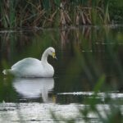
Whooper Swan, Cloddach quarry 2 September 2025 (Martin Cook)
2/9/2025 (11:00) Ruff 1, Kingfisher 1 Spey estuary (east side) Martin Cook
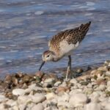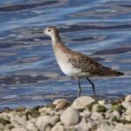
Ruff, Spey estuary 2 September 2025 (Martin Cook)
2/9/2025 (pm) Arctic Skua 1, Great Skua 1, Whimbrel 2 off Delnies Dave Pullan
2/9/2025 (14:00) Whimbrel 1, Black-tailed Godwit 2, Greenshank 1, Curlew 60+, Greylag Goose 22, Pink-footed Goose 1 Spey estuary (west side) Raymond Shewan
1/9/2025 (13:15) Little Gull 1 (adult) Lossie estuary Graham & Sue Larrington
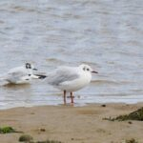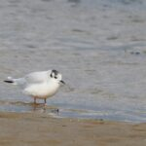
Little Gull [left with Black-headed Gull], Lossie estuary 1 September 2025 (Graham Larrington)
1/9/2025 Pomarine Skua 1, Sandwich Tern 12, Bar-tailed Godwit 3 Nairn harbour Paulo Bessa
1/9/2025 Goshawk 1 near Loch Dallas Paulo Bessa
1/9/2025 (10:30-11:30) Ruff 2, Greenshank 1, Gadwall 3, Wigeon 18, Teal 33, Canada Goose 25 Spey estuary (east side) Martin Cook
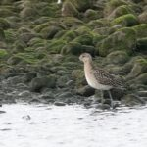
Ruff, Spey estuary 1 September 2025 (Martin Cook)

